**LESSON NOTES FOR R.E P.3 TERM II – 2024**

**Week I**

**Lesson One**

**Jesus gives us the Holy Spirit.**

* Read John 4: 15 – 18
* Jesus promised his disciples a helper
* The Holy Spirit is the helper Jesus promised his disciples
* The day Jesus went back to heaven is called **Ascension day** (read: Act 9: 11)

**Why did Jesus promise the Holy Spirit to the disciple**

* To comfort them
* To guide them
* To give them power
* To teach them
* The Holy Spirit came on to the disciples on Pentecost day

**Exercise**

1. Who said “Behold, I send you a helper”?
2. Which helper was promised?
3. Give two reasons why Jesus sent us the Holy Spirit.
4. On which day did the Holy Spirit come on the Apostles?

**Lesson two**

**Events that happened on Pentecost day**

(Read Act 2: 1 – 4)

* There was a loud voice from heaven
* The Holy Spirit came upon the disciples in form in flames of fire.
* They started speaking different tongues or language.
* Peter started preaching.

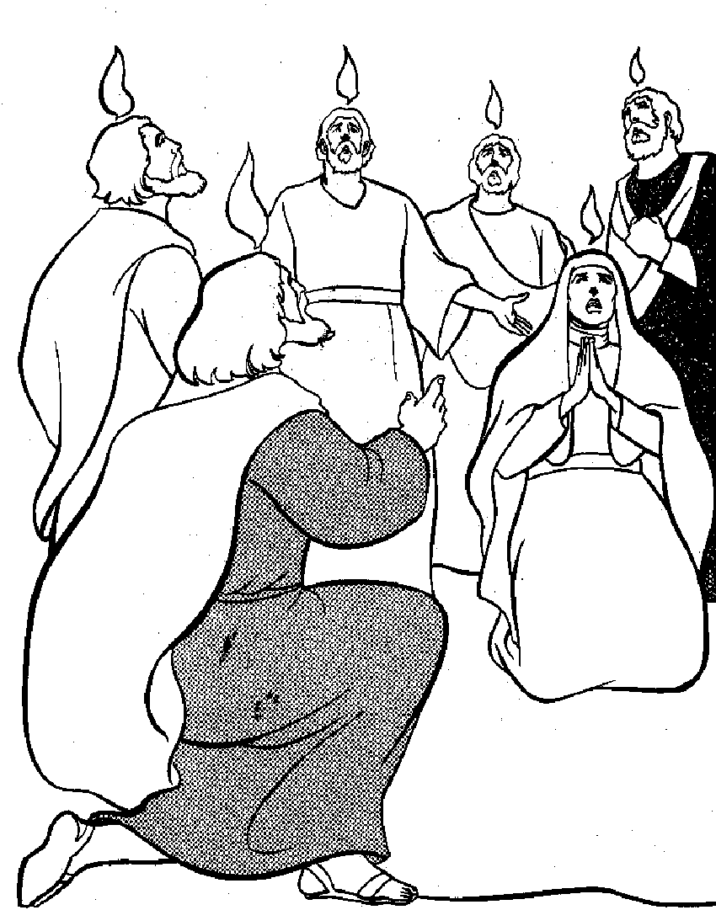

**Exercise**

1. In which form did the Holy Spirit come on the disciples?
2. Name any two events that happened on Pentecost day.
3. Who preached on Pentecost day?
4. Draw and colour flames of fire as the Holy Spirit appeared upon the disciples.

**Week: 2**

**Lesson one**

**How the Holy Spirit helped the early Christians**

(Read Act 3: 38 – 47)

**Ways how the Holy Spirit helped the apostles.**

* To preach the word of God
* It enabled them to perform miracles
* To live and share things together
* To endure hardships
* To speak to leaders without fear.

**How the Holy Spirit helps us today**

* To know what is right or wrong
* It gives us hope in times of trouble
* It protects us from sin and Satan
* It guides us in prayer and worship
* It helps us to endure hardships

**Exercise**

1. State two ways how the Holy Spirit helped the first Christians.
2. Mention four ways how the Holy Spirit helps Christians today.

**Lesson two**

**Gifts of the Holy Spirit and how to use them**

What is a gift?

A gift is something you receive without working for it.

The following are the gifts of the Holy Spirit

(read 1 Corinthians 12: 1 – 12)

There are nine gifts of the holy spirit, namely

* wisdom
* faith
* healing
* working miracles
* prophecy
* speaking in tongues
* interpreting tongues
* knowing a person with an evil spirit (discernment)

**Exercise**

1. What is a gift?
2. Give any four gifts of the Holy Spirit.

**Week: 3**

**Lesson one**

**Activities we do today when guided by the Holy Spirit.**

* reading the Bible
* praying together
* sharing experiences
* sharing meals
* Selling possession to help one another
* Preaching the word of God

**Exercise**

1. List down the activities we do together when guided by the Holy Spirit.

**Lesson two**

**The worshiping community**

What is worship?

Worship is the way of praying and showing respect to God.

**Ways of worshiping God**

**(Read Psalms 150: 1 – 6)**

* offering to God
* reading the bible
* singing hymns/religious songs
* dancing
* fasting
* preaching
* caring for those in need
* waving hands
* praying
* listening to the words of God
* clapping

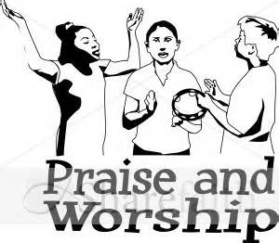

**Reasons why Christians worship God (Psalms 100:1 – 5)**

* To show that he is great
* To forgive them their sins
* To show love to him
* To show that he is holy
* To give them their needs
* To show that he is above all other gods.
* To give them good health
* To thank God

**Exercise**

1. What is worship?
2. Give three ways of worshipping God.
3. State two reasons why Christians worship God.
4. Draw people worshipping God.

**Week four**

**Examples of people who worshipped God in the Bible**

* King David worshipped God by singing and dancing.
* Isaac
* King Solomon
* Jacob
* Daniel

**Some ways Christians worship God**

* Christians worship by singing and praying

**Importance of singing**

* Singing makes Christians feel Joy and happiness.
* Singing makes God happy too
* Christians worship by offering
* Offering means giving something to God to thank him or show love to him

**Things which Christians can offer to God**

* money
* property
* animals
* food

**Types of offerings**

* Thanks giving offerings
* Special offering
* Tithe (Malachi: 3: 1 – 5)

**Exercise**

1. Give three examples of people who worshipped God in the Bible.
2. Mention any two things Christians can offer to God.
3. Outline one type of offering.

**Lesson two**

**Praying to God (Read Mathew 6: 5 – 8)**

**What is prayer?**

* Prayer is a special way of talking to God.

**Things Christians do before praying**

* Repenting (ask God for forgiveness)
* humble himself/herself
* Turn his/her minds towards God
* Kneel down to pray

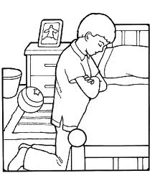

**Reasons why people pray to God**

* To ask for forgiveness
* To ask for protection
* To get blessings
* To thank God for what he has done
* To get daily needs like food, clothes etc

**When do we pray?**

* before a meal
* before sleeping
* after bed
* when in trouble
* when going for a journey etc

**Exercise**

1. What is prayer?
2. Write two things a Christian should do before praying
3. Give two reasons why people pray
4. Draw yourself praying.

**Week five**

**Lesson one**

**Types of prayer (read: Matt 7:7 – 11)**

* personal prayer
* Thanks giving prayer
* Confession prayer
* Petition prayer

**What is a personal prayer?**

* A personal prayer is a prayer said by a person when he/she is alone.
* In a personal prayer, one can tell God whatever he/she wants from God.
* Thanks giving prayer is a prayer to thank God.
* A confession prayer is a prayer to confess our sins.
* A petition prayer is a prayer which makes requests to God.
* Intercession prayer is a special prayer you pray for other people e.g. the sick.

**Exercise**

1. Define a personal prayer?
2. Name two types of personal prayers.
3. Which type of prayer is said to ask for forgiveness.

**Lesson two**

**People who need to be prayed for**

* children
* the sick
* the prisoners
* pregnant women
* teachers
* the war victims
* the leaders
* the dumb and deaf
* parents
* the mad people

**Places where we can pray from**

* You can pray from anywhere in case you feel to pray
* You can also pray from the following places
* from the church
* classroom
* bedroom
* in a vehicle
* on the mountain or hill

**Examples of people who prayed to God and they were answered**

* Abraham
* Jacob
* King David
* Daniel
* Simon Peter
* Jesus
* Samson
* Ruth
* Jeremiah

**Exercise**

1. Name three groups of people who should be prayed for.
2. Apart from a church, where else can a Christian pray from?
3. What do you know about these people in the Bible?
4. Samson
5. Daniel

**Week 6**

**Lesson one and two**

**The Lord’s Prayer**

(Read Matthew 6: 9 – 14)

What is the Lord’s Prayer?

* This is the prayer Jesus taught his Apostles

**Note:** Recite the Lord’s Prayer

**Requests made in the Lord’s Prayer**

* God’s kingdom to come
* God’s will to be done
* To give us our daily food (bread)
* To forgive our trespasses (sins)
* Protection from the devil’s temptation
* To deliver us from evil

**Lessons we learn from the Lord’s Prayer**

* To glorify/praise God
* To ask for God’s kingdom to come
* To ask God for deliverance in case of trouble

**Exercise**

1. Which prayer did Jesus teach his Apostles?
2. Identify any three requests made in the Lord’s Prayer.
3. Why do you think Jesus taught his disciples this prayer?

**Week 7**

**Lesson one**

**The teaching of Jesus**  
(Read Matt 5:43 – 48)

* Jesus teaches us Christian values what are values?
* values are belief about what is right and wrong

**Examples of Christian values**

* being honest
* being responsible
* helping others
* being faithful
* kindness
* trust worth
* loving one another
* respecting elders
* patience

**How Jesus helped others**

* he healed the sick
* he fed the hungry
* he raised the dead
* he healed the deaf and the dumb
* he healed the blind

**Exercise**

1. Name any two Christian values.
2. Mention two needy groups of people.
3. Identify three ways you can help the needy.

**Lesson two**

**Explaining some Christian values**

1. **Honesty**

Honesty means being trustful. An honest person is a person who tells the truth. Christian must be honest

1. **Patience**

Patience means being able to wait for the right time of something

1. **Responsibility**

Responsibility means doing what you are supposed to do.

**Ways of being responsible**

* Never say/see something which in not in order and you just leave it
* Always attend to your roles or work in time.
* Share roles equally so as to work well responsibilities of home
* make a list of your roles or responsibilities at home

**Exercise**

1. What does the word honesty mean?
2. What are responsibilities?
3. State any three ways of being responsible.

**Week 8**

**Lesson one**

**Parables taught by Jesus**

What is a parable?

A parable is a short story with a hidden meaning

**Examples of parables used by Jesus**

* The parable of the sower (mark 4:1 – 9)
* He parable of the lost son or prodigal son (Luke 15: 11 – 31)
* The parable of the good Samaritan (Luke 10: 25 – 37)
* The parable of the ten virgins (matt 25: 1 – 13)
* The parable of the lost sheep (Luke 15: 1 – 7)
* The parable of the lost coin (Luke 15: 8 – 10)
* The parable of the talents (Matt 25: 1 – 13)
* The parable of the tenants (Luke 20: 9 – 16)

**Why Jesus used parable**

* He didn’t want his enemies to know what he was saying.
* For the disciples to understand well
* he wanted to make his messages clear
* To fulfill what was said about him

**Exercise**

1. Define a parable.
2. Name four parables in the Bible.
3. Give two reasons why Jesus used parables in His teachings

**Lesson two**

**Characteristics of God found in Jesus**

(Read John 3:16)

* Children adopt some characteristics form their parents.
* Jesus also had characteristics from God His father. These were:-

love, kindness, holiness, divine power

* being eternal
* knowing people’s thoughts
* knowing the past, present and the future

**Exercise**

1. Identify four things which show that Jesus was the son of God.
2. Name the three persons in the holy trinity.
3. Why did God send His son on earth?

**Week 9**

**Lesson one and two**

**God given abilities (talents)**

Read: Matt 25: 1 – 13

What is a talent?

A talent is a gift from God

Talents are not learnt but are natural

**Examples of talents or God given abilities**

* singing
* dancing
* drama
* drawing
* painting
* playing games and sports
* good public speaking
* making handwork or Art/crafts

**Examples of people with God given abilities**

* runners like the Uganda gold medalistStephen Kiprotich – who won the world marathon, races two times.
* Singers – Mention some singer you.
* Footballers: Mention some talented footballers you know.

**How to use your talents well**

* Use your talents to earn a living
* use it to help others
* use it to glorify God
* use your talent to glorify your community
* Do not hide your talent
* Use your talent to make it perfect
* Never be proud

**Exercise**

1. What is a talent?
2. Name two talents God gave us.
3. What is your talent?
4. State any two ways you can use your talent well.
5. How can one misuse his/her talent?
6. Name the Ugandan who won two gold medals in world marathon races.